Week 4 1103 – LAB 04

4. Docker Mount and Run
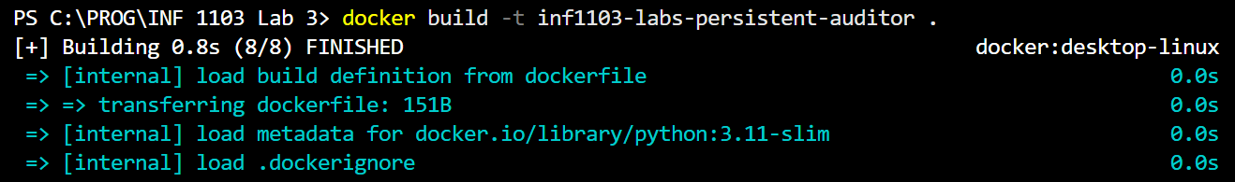
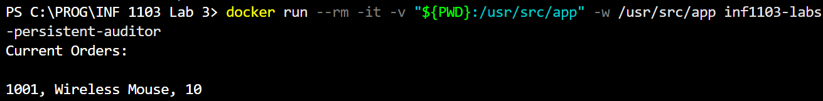

5. Docker Image
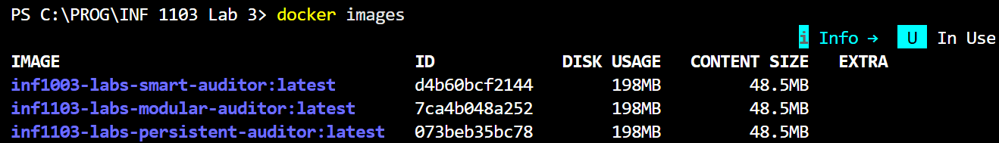
6. Docker Run
